#### Practice 1:Write a JavaScript function to check whether a string is blank or not.

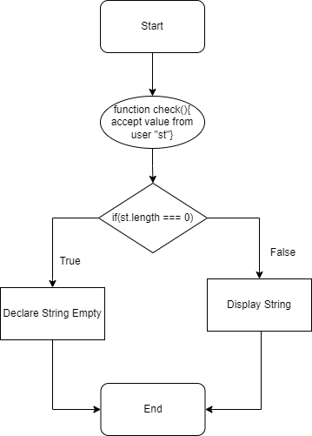

Practice 2:Write a JavaScript function to split a string and convert it into an array of words

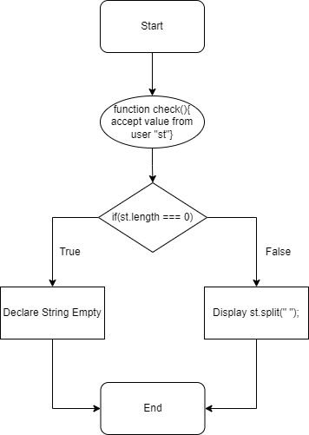

Practice 3:Write a JavaScript function to extract a specified number of characters from a string.

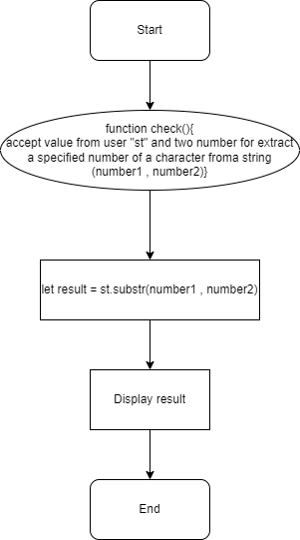

Practice 4:Write a JavaScript function to get the current date.

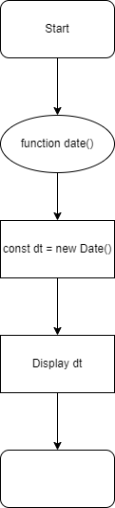

Assignment 1:Date entered by the user should be checked for whether it is a Valid Date or not.

